**MAIS 202 - PROJECT DELIVERABLE 3**

**1. Final Training Results**

The goal of the project has been changed slightly. The project now is targeted to recognize handwritten english letters which have 26 classes, instead of the chinese characters.

CNN is used as the model to train the data.

Accuracy: 0.9961

val_loss: 0.0338

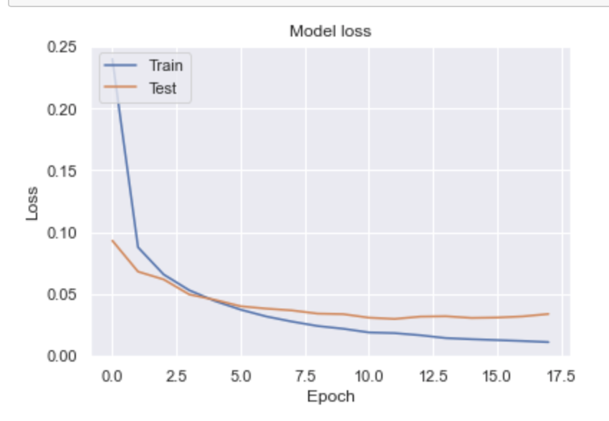

**2. Final demonstration proposal**

For demo, I will use a website to demonstrate the project.

The idea is to provide an input image to the model and then output will be shown.

* Presentation tip:

Problem: how to identify the handwritten english letter using ML?

Potential application:

A variant of the model: A simple encode to the message: define the symbols corresponding to every english letter and recognize the handwritten paragraphs and translate to the new language system.